DEPRESSION ANALYSIS OF STUDENTS

Submitted by: | Submitted to:
Ajay V M | Shilpa E V

21/10/2025

- CONTENTS

- Introduction
- Data set Description
- Data Cleaning and Preprocessing
- Exploratory Data Analysis
- Conclusion

- INTRODUCTION

This Project aims to analyse the Students Depression using Python Libraries Like Pandas, Numpy and Matplotlib.
The global crisis in student mental health, characterized by a rising prevalence of depression and anxiety, poses a significant challenge to academic institutions and public health. College and university students face a unique confluence of stressors—including intense academic pressure, financial strain, sleep deprivation, and the transition to independent living—which places them in a high-risk demographic for developing depressive symptoms. If unaddressed, this can lead to impaired academic performance, social withdrawal, and long-term health consequences.
The increasing availability of structured data offers a powerful opportunity to move beyond traditional diagnostic methods and employ data science techniques for proactive identification and intervention.
The primary goal of this project is to apply data-driven methods to analyse and predict depression risk among students, enabling targeted and early intervention strategies.
- Examine Data Distribution
- Analyse Demographic Skew
- Identify Missingness and Outliers

- Dataset Description

Column Name | Description | Data Type
Id | Unique id of students | Integer
Gender | Gender of Students | Object
Age | Age of Students | Integer
City | City of students | Object
Profession | Profession of students | Object
Academic Pressure | Pressure of students | Integer
Work Pressure | Pressure of Work | Integer
CGPA | Percentage of students mark | Float
Study Satisfaction | Satisfaction level of study | Integer
Job Satisfaction | Satisfaction level Job | Integer
Sleep Duration | Sleeping time of students | Object
Dietary Habits | Dietary habits of students | Object
Degree | Degree of students | Object
Have you ever had suicidal thoughts | Suicidal thoughts of students | Object
Study Hours | Study hours of students | Integer
Financial Stress | Stress faced by students | Object
Family History of Mental illness | Family history of students | Integer
Depression | Depression level of students | Category

Dataset Source : Kaggle Total Columns : 18 Total Rows : 27870

- Data cleaning and Preprocessing

- Imported dataset using pandas.read_csv
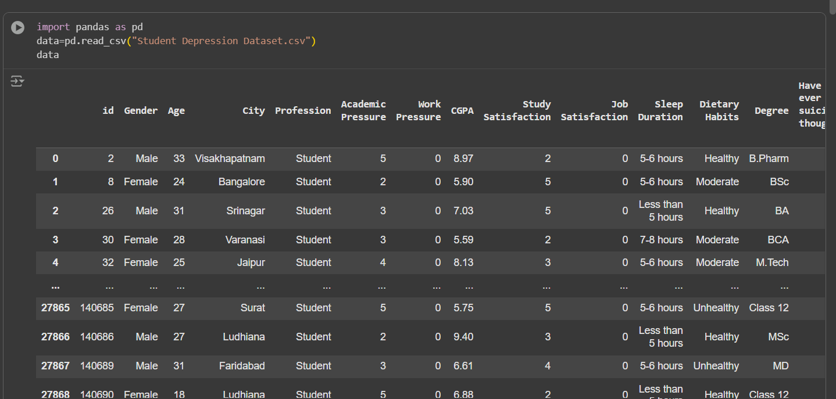

- Checked for description using describe()
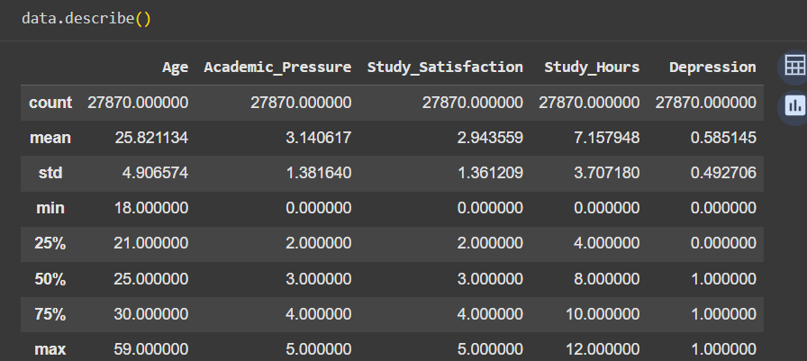

- Checked for information using info()
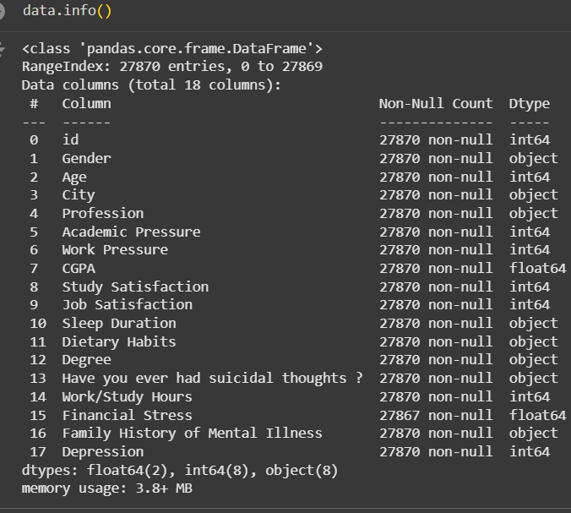

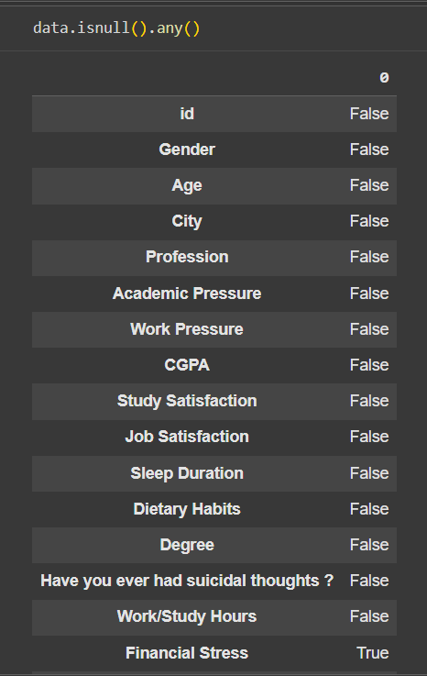
- Checked for missing values using data.isnull()

- Drop column names using drop()
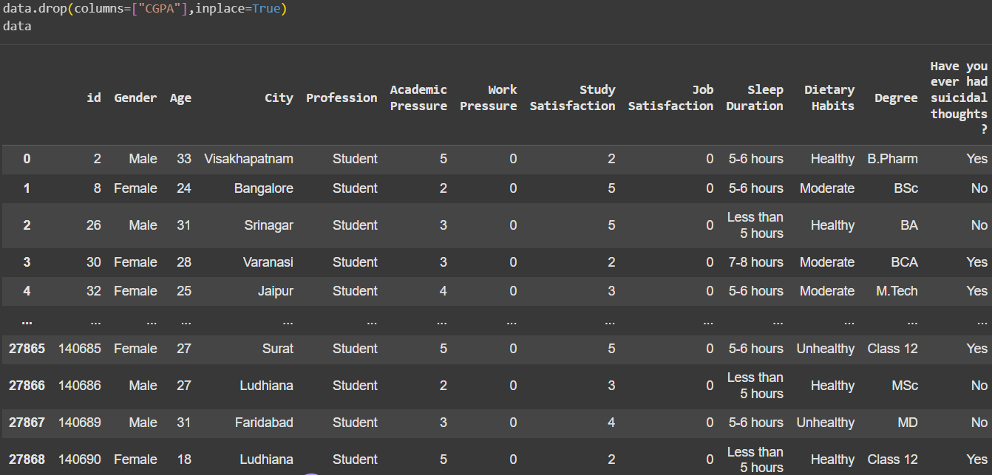

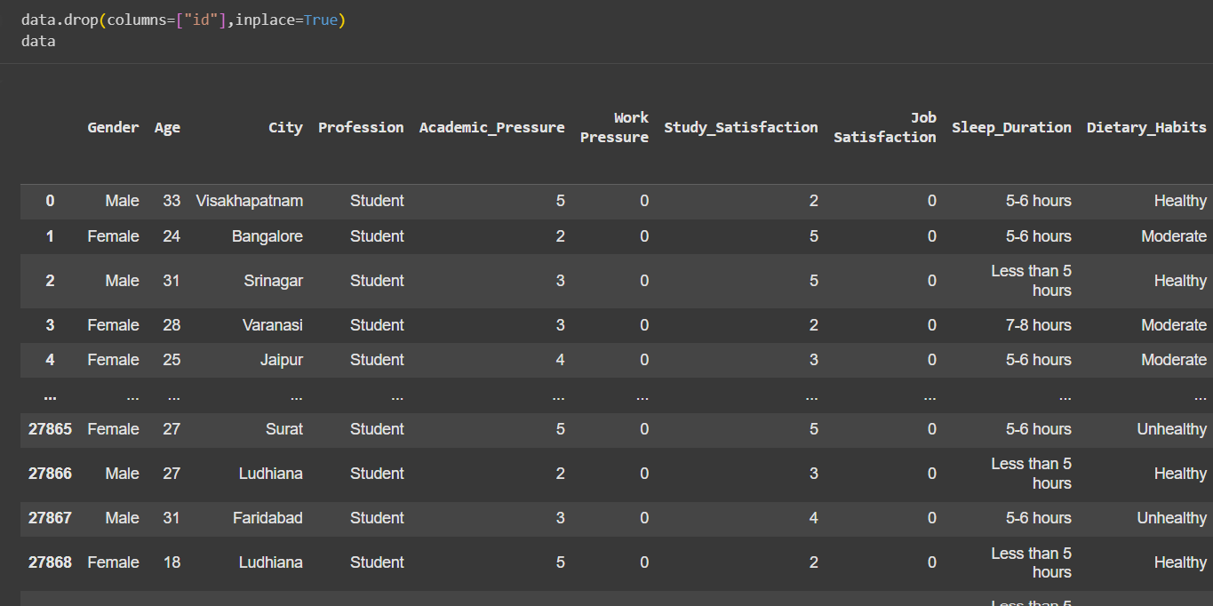

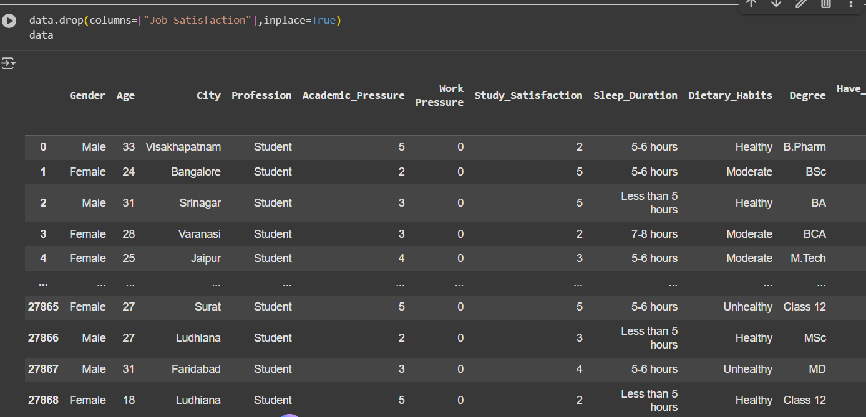

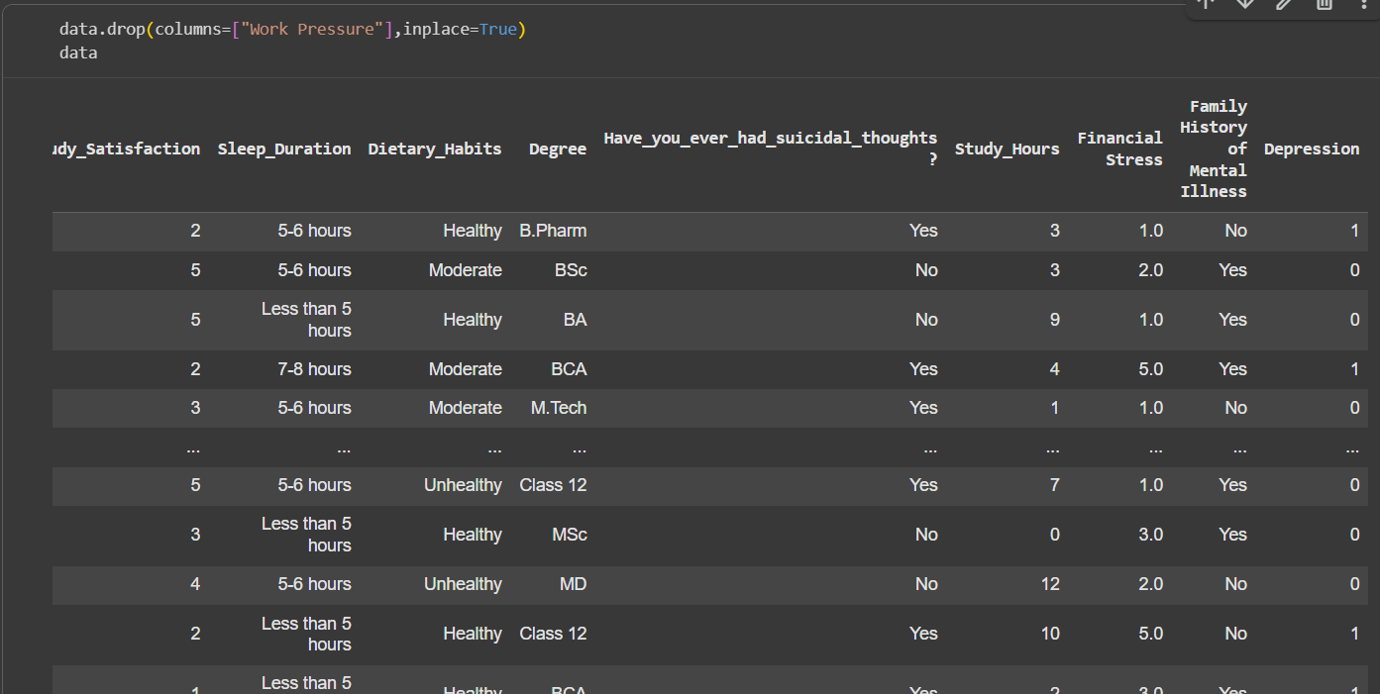

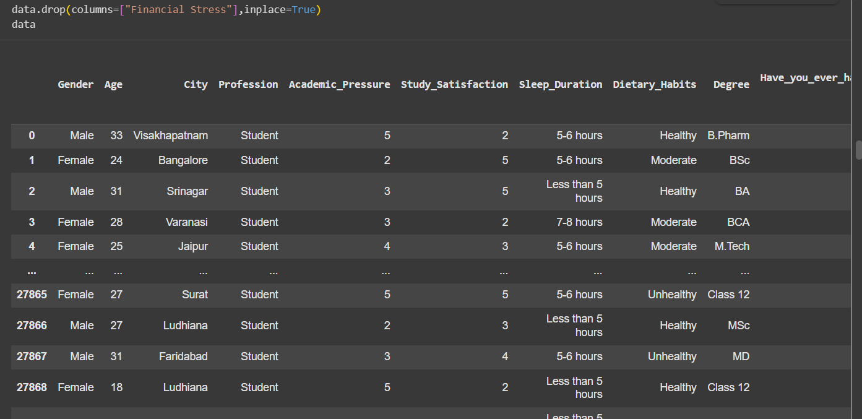

- Rename column names using rename()
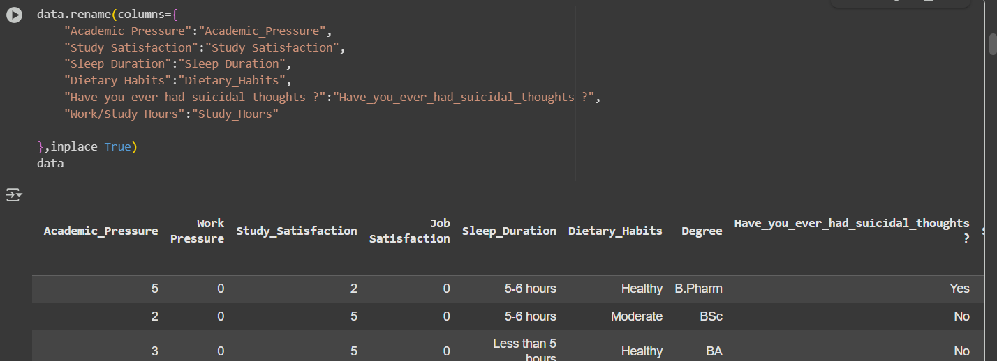

- Exploratory Data Analysis

- Bar Chart - Sleep Duration across Age Groups
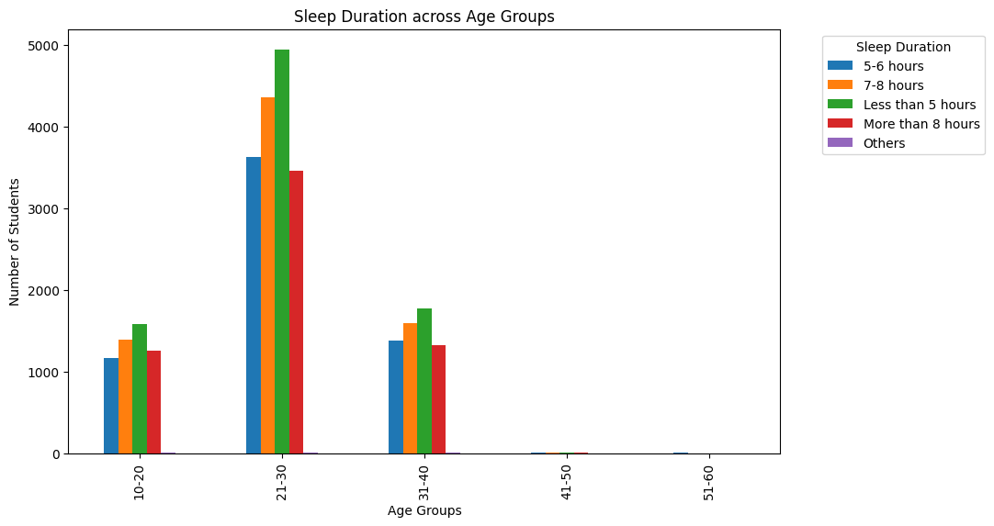

Interpretation: The bar chart compares the number of students across different age groups based on their average sleep duration. The sleep durations are categorized as Less than 5 hours, 5–6 hours, 7–8 hours, More than 8 hours, and Others.

- Bar Chart - Sleep Duration across Degree Students

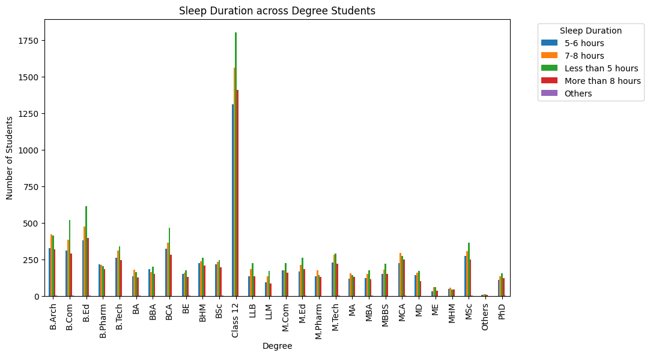

Interpretation: The bar chart displays the sleep duration patterns of students from various academic degrees. The sleep durations are grouped into five categories — Less than 5 hours, 5–6 hours, 7–8 hours, More than 8 hours, and Others — while the x-axis lists different degree programs, ranging from undergraduate to postgraduate and doctoral levels.

- Pie Chart - Dietary Habits of Students.

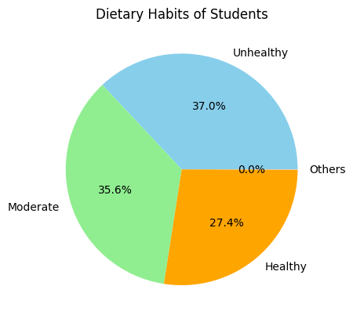

Interpretation:

The pie chart presents the distribution of dietary habits among students, divided into four categories — Unhealthy, Moderate, Healthy, and Others.

- Bar Chart - Suicidal thoughts of Degree Students
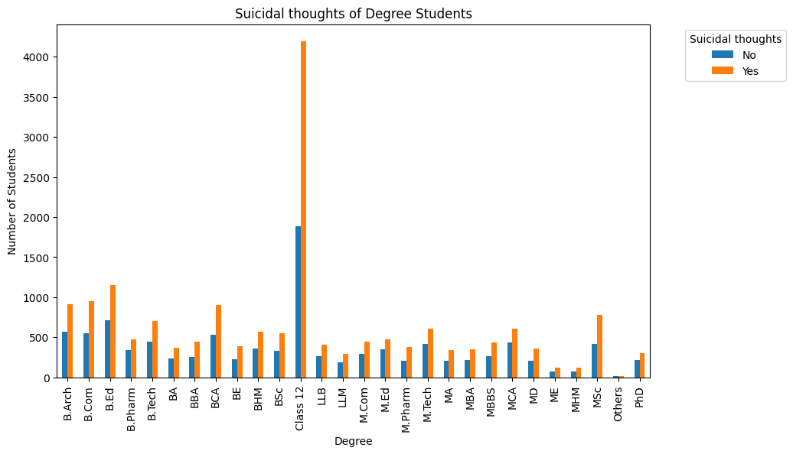

Interpretation : The chart compares the number of students across various degree programs who have and have not experienced suicidal thoughts. It provides insights into the prevalence of suicidal ideation among different academic streams.

- Pie Chart - Suicidal thoughts by Gender
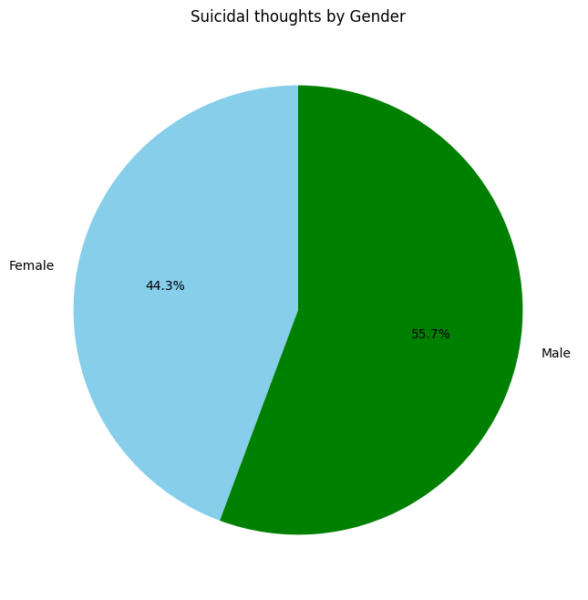

Interpretation : The pie chart illustrates the distribution of students who reported having suicidal thoughts, categorized by gender — Male and Female.

- Bar Chart - Total Depression Cases by Degree
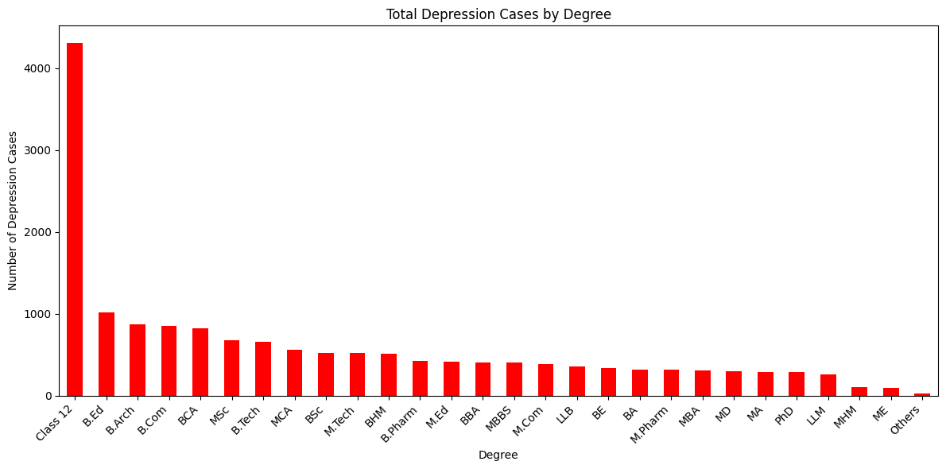

Interpretation: from this table we analyse total depression cases by degrees. it express more in class 12 and low in others.

- Bar Chart - Dietary Habits of Degree Students
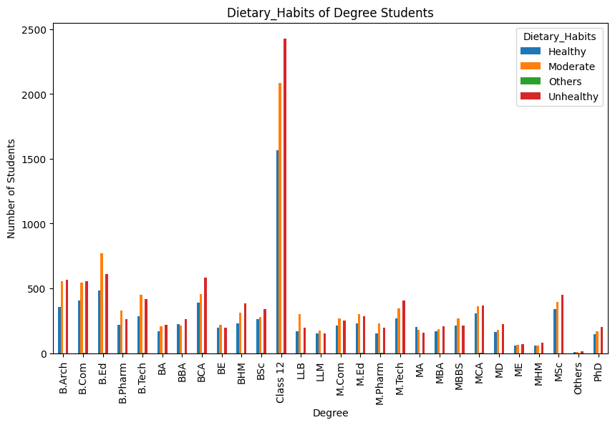

Interpretation: The bar chart compares the dietary habits (Healthy, Moderate, Others, Unhealthy) of students pursuing different degrees. The y-axis shows the number of students, while the x-axis lists different academic degrees.

- Bar Chart - Students by City

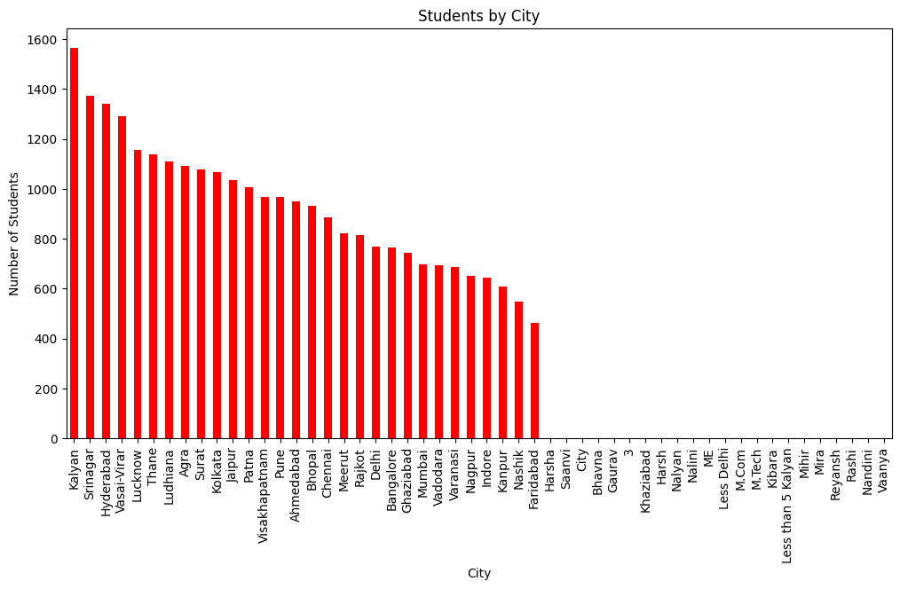

Interpretation: The chart shows the number of students from various cities, with each bar representing a city and its corresponding student count. The y-axis indicates the number of students, while the x-axis lists the cities.

- Line Chart - Line plot of Depression
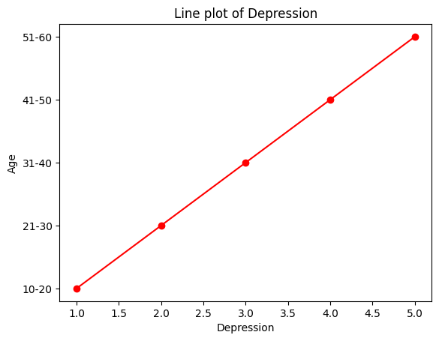

Interpretation: The chart shows a line plot depicting the relationship between Age groups (on the y-axis) and Depression levels (on the x-axis). Each red point represents the average or relative depression level for a specific age group.

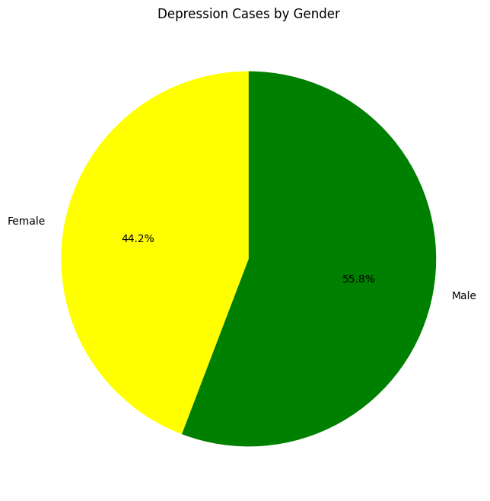
- Pie Chart - Depression Cases by Gender
Interpretation: The pie chart provides a straightforward breakdown of a population or sample based on gender, specifically showing the distribution between Male and Female.

- Conclusion

Depression among students is a serious and growing concern that affects their academic performance, emotional well-being, and overall quality of life. Academic pressure, social expectations, and personal challenges often combine to create a stressful environment that many students struggle to manage. It is essential for schools, parents, and society to recognize the signs of depression early and provide proper support systems such as counsiling, mental health education, and a safe space to talk. By promoting awareness and encouraging open discussions about mental health, we can help students overcome depression and build a more positive, balanced, and resilient future.

